Tamarack City Council Final Negotiation





# Roadmap

Overview

Strategy

Conclusion



Stakeholder Analysis

Start and End to Negotiation Process Analysis

What We Learned

HARRINGTON 2

# Overview





Jonathan - Mayor Hannah - Chairperson

OUR ROLES

Lauren - Council Member and Veterinarian Nathan - Council Member and Restaurant Owner Miranda - Council Member and Loan Officer Kelsey - Council Member and Travel Agent

HARRINGTON 3

# Stakeholder Analysis



* Interests
  + Keeping Twin Lakes Mining open
  + Spending/changing taxes as little as possible
  + Improving environmental conditions
* Goals
  + Pay less than half of overall expenses for water filtration
  + Twin Lakes pay for roads, we pay maintenance
  + Not changing the tax package
* Power
  + We hold power to keep them open
  + They hold the power to crash the town’s economy

MILLER 4

 



# Strategy

* Collaborative



* + Negotiation bingo
  + Extremely transparent
  + Ask “why”
* Opening offer
  + We take out the bond for them, but they

repay 100% of principal and interest

* + Twin lakes pays for the roads & the city pays for maintenance
  + No change in the taxes and property
* Walkaway point
  + Less than 50% payment of the bond and Twin lakes refusal to pave and maintain their portion of roads
* BATNA
  + 60/40 split on the bond interest
  + We each pay for our own pavement and maintenance of the roads
  + Sell the property for 2 million without a tax change
* Tactics
  + Forbearance
  + Taking breaks for any major shift in negotiation

STURGILL 5

# Starting the Negotiation Process Analysis



## Twin Lakes Mining Company hosted the meeting

* Both teams were dispersed around large table
  + Discussed benefits for both teams in our collaboration goal

## Began with introductions

* Wrote initial offers on the board
  + Took a break to discuss

## Interest based

* + Both parties had the interests of cleaning up the problem for the EPA

GUY 6

# Ending the Negotiation Process Analysis



## Did we stick to our beginning strategy?

* Twin lakes put a top dollar offer on the board for consideration
  + Exercised trust
  + Used collaboration to come to a decision best for both teams
  + Win-win to preserve relationship and benefit from outcome

GUY 7

# Conclusion

## Agreement was reached after a very long negotiation

   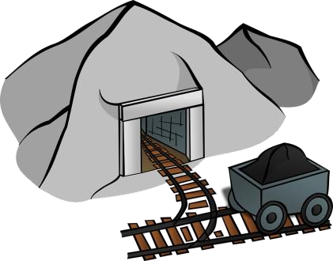

Twin Lakes pays $4.8 million capital investment, city pays

$600,000 annual

maintenance.

Twin Lakes pays $19.2 million capital investment plus 50% of the interest, city pays the other 50% interest.

No sale of land at this time. However, Twin Lakes received a

$300,000 tax cut from

the city.

The city will receive

$100,000 annually from the sale of excess ore from processing.

HORVATH 8

# See the source imageWhat We Learned

* Research, research, research
* Real world situation
  + Company vs. city
* Was anything unique to this negotiation?
  + Power dynamic
  + Restrictions
* Buy *Finance For Dummies*

SPACER 9